Monday, December 3rd
8:00 – 9:00: Registration

9:00 – 9:30: Diagnosing & Managing Cotton and Soybean
Diseases
Dr. Tom Allen – Mississippi State University

9:30 – 10:00: Managing Nematodes in Cotton & Soybean
Dr. Travis Faske –University of Arkansas

10:00 – 10:30: Soybean Taproot Decline Update &
Management Alternatives
Dr. Trey Price – Louisiana State University

10:30 – 11:00: Diagnosing & Managing Peanut Diseases
Dr. Bob Kemerait – University of Georgia

11:00 – 11:30: Where Does Your Fertilizer Come From &
What Determines Cost
Dr. Trey Cutts – Yara North America

11:30 – 12:00: Fertilizer Requirements for High Yielding Yet Profitable Crop Production
Dr. Bobby Golden – Mississippi State University

12:00 – 1:00: Lunch – Charlie Williams Catering

1:00 – 1:30: Cover Crops & Soil Health
Dr. Bill Robertson – University of Arkansas

1:30 – 2:15: How Diversification & Focus on Soils Has Improved Productivity on My Farm
Mr. Adam Chappell – Grower – Cotton Plant, AR

2:15 – 2:45: Peanut Weed Control
Dr. Eric Prostko – University of Georgia

2:45 – 3:15: Landscape Level Impact of Off-Target Herbicide Movement & How This Impacts Potential Legislation
Dr. Stanley Culpepper – University of Georgia

3:15 – 3:30: Break

3:30 – 4:00: Tracking Down Off-Target Movement of Herbicides: Tip & Tricks from the Master
Dr. Eric Webster – Louisiana State University

4:00 – 4:30: Detecting Dicamba & 2,4-D in Plant Tissue: What Are the Possibilities?
Dr. Ashli Brown – Mississippi State University

4:30 – 5:00: Herbicide Application Timing: Effect on Weed Control Efficacy
Dr. Jason Bond – Mississippi State University

6:00 – 10:00: Social Mixer with Heavy Hors D’oeuvres
Cotton Mill Conference Center
Live Music: Ms. Mallory Everett
Tuesday, December 4th

8:00 – 8:25: Insecticide Resistance Monitoring and the Role of Novaluron on Tarnished Plant Bug Populations
Dr. Fred Musser – Mississippi State University

8:25 – 8:50: Corn Insects: Management Options for Maximizing Profits
Dr. Don Cook – Mississippi State University

8:50 – 9:35: Management of Caterpillar Pests in Soybeans
Dr. Gus Lorenz – University of Arkansas

9:35 – 10:00: Impact of Cover Crops on Soybean Insect Management
Mr. Adam Whalen – Mississippi State University

10:00 – 10:15: Break

10:15 - 10:40: Management of Bollworms in Bt Cotton in LA: Experiences to Date
Dr. Sebe Brown – Louisiana State University

10:40 – 11:05: Management of Bollworms in Bt Cotton in MS: Experiences to Date
Angus Catchot – Mississippi State University

11:05 – 11:30: Economics of Managing Insect Pests of Cotton
Dr. Jeff Gore – Mississippi State University

11:30 – 12:00: Effect of Temperature Inversions on Off-Target Movement of Pesticides
Dr. Richard Grant – Purdue University

12:00 – 1:00: Lunch – Charlie Williams Catering

1:00 – 1:25: A Snapshot of Mississippi Agriculture
Mr. Andy Gipson – MS Commissioner of Agriculture

1:25 – 2:10: Planter Technology: Making a JD 7100 a Million Dollar Machine
Mr. Jason Webster – Precision Planting

2:10 – 2:55: Sulfur Nutrition in Row Crops: Hidden Hunger?
Dr. Ross Bender – Mosaic Company

2:55 – 3:20 A Closer Look at Potassium Deficiency in Cotton
Dr. Tyson Raper – University of Tennessee

3:20 – 3:45 Break

3:45 – 4:10: Maximizing Soybean Production in 2019
Dr. Trent Irby – Mississippi State University

4:10 – 4:35: Corn Seed Depth Impacts on Soil-Water Relations
Dr. Erick Larson – Mississippi State University

4:35 – 5:00: Economics of Cotton Fertility Management
Darrin Dodds – Mississippi State University

6:00 – 10:00: Steak and Shrimp Dinner and Social Event
Cotton Mill Conference Center
Live Music: Ms. Mallory Everett
Wednesday, December 5th

8:00 – 8:30: Soil Amendments & Water Considerations in Mississippi Peanut Production
Dr. Brendan Zurweller – Mississippi State University

8:30 – 9:00: Productive & Profitable Peanuts: A Consultant’s Perspective
Mr. Trey Bullock

9:00 – 9:30: Economic Outlook for Mississippi Row Crops in 2019
Dr. Larry Falconer – Mississippi State University

9:30 – 10:00: Seed Cotton Program Information & Status of the New Farm Bill
Dr. Mike Deliberto – Louisiana State University

10:00 – 10:15: Break

10:15 – 10:45: Tariffs & Trade Wars: Potential Effects on Mississippi Agriculture
Dr. Keith Coble – Mississippi State University

10:45 – 11:15: Chronic Wasting Disease: Facts & Figures
Dr. Steve Demarais – Mississippi State University

11:15 – 11:45: Ag Theft: Investigating Theft of Everything From Bulls to Bulldozers
Mr. George Brown – MS Dept. of Agriculture & Commerce Agricultural Theft & Livestock Bureau

11:45: Lunch – Charlie Williams Catering

Consultant’s License Renewal For:
Entomology
Plant Pathology
Weed Control

Pesticide Applicator Re-Certification for the Following:
Category 1A – Agricultural Pest Control – Plant
Category 10 – Research and Demonstration Pest Cont.

Certified Crop Advisor CEU Availability:
Pest Management – 7.0
Crop Management – 5.5
Nutrient Management – 3.0
Soil and Water – 2.5
Professional Development – 0.5
Platinum Level Sponsors ($3,000):

Gold Level Sponsors ($1,500):

Silver Level Sponsors ($1,000):

Bronze Level Sponsors ($500):
Notes:

Mississippi State University is an equal opportunity institution. Discrimination in university employment, programs, or activities based on race, color, ethnicity, sex, pregnancy, religion, national origin, disability, age, sexual orientation, genetic information, status as a U.S. veteran, or any other status protected by applicable law is prohibited. Questions about equal opportunity programs or compliance should be directed to the Office of Compliance and Integrity, 56 Morgan Avenue, P.O. 6044, Mississippi State, MS 39762, (662) 325-5839.
For disability accommodation, please contact Ms. Kathy Johnson at 662-325-2311
2018 Program
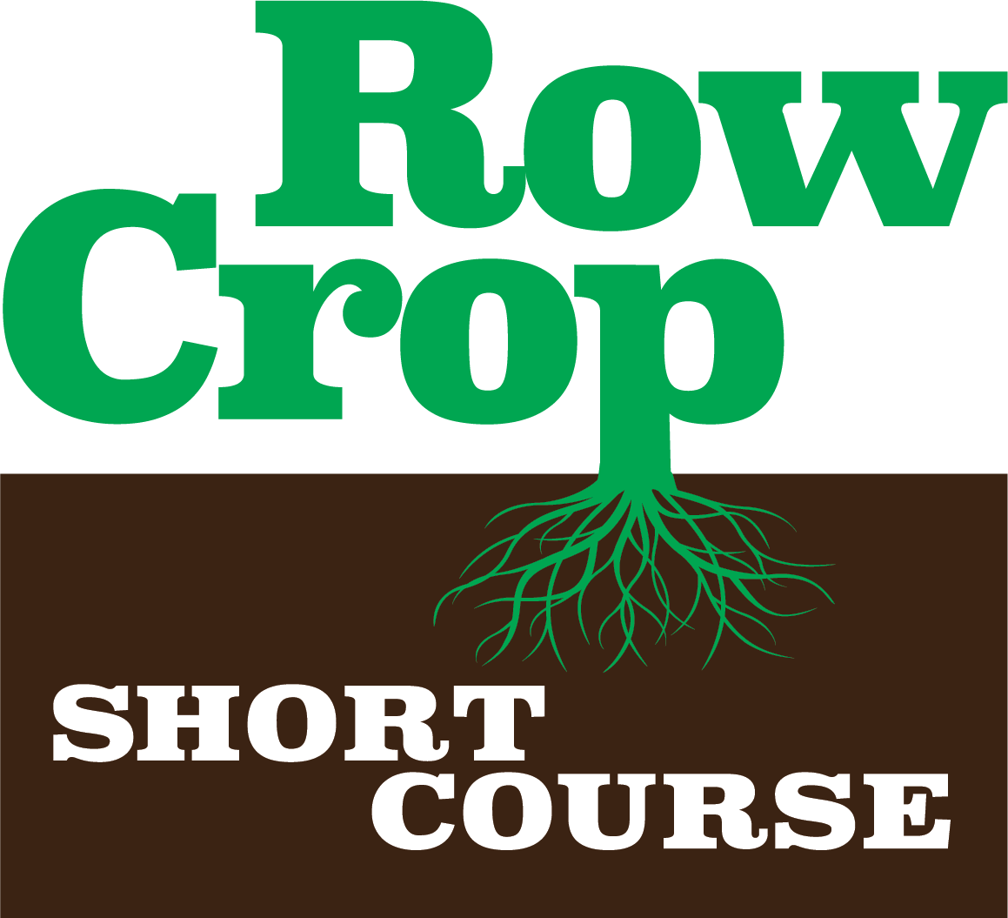

Follow Us on Social Media:

Facebook: Mississippi Crop Situation

Twitter: @mscrops

Instagram: mississippicrops

