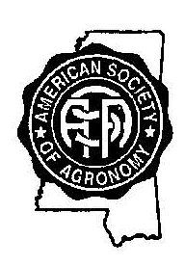
MISSISSIPPI CHAPTER
AMERICAN SOCIETY OF AGRONOMY
ANNUAL MEETING
Wednesday, November 15, 2017
Grenada County Extension Service - Grenada, MS

ADVANCED REGISTRATION FORM

REGISTRATION FEE - $45.00 (Includes meals, membership dues and meeting registration)

NAME:
ORGANIZATION:
EMAIL ADDRESS:
MAILING ADDRESS:
 | (Street/Box)
 | (City) | (State) | (Zip Code)
TELEPHONE:
 | (Office) | (Home or Cell)

PLEASE RETURN COMPLETED FORM
ON OR BEFORE November 8, 2017, TO:

David Roberts
MS-ASA Secretary
50035 Arrowhead Trail
Amory, MS. 38821
Email: john.david.roberts62@gmail.com
662-257-5527

*Registration for fully retired MS ASA Members and Students will be $10.00
*Not attending the meeting, but paying for dues will be $30.00
*Registration fee at the door will be $65.00
Make Check payable to: MS Chapter - ASA

