Monday, December 2nd
8:00 – 9:00: Registration

9:00 – 9:30: CLRDV: What We Know and What We
Don’t
Dr. Tom Allen – Mississippi State University

9:30 – 10:00: Distribution and Symptomology from
CLRDV: An Alabama Perspective
Dr. Austin Hagen – Auburn University

10:00 – 10:30: Impact of CLRDV on Plant Development and Yield
Dr. Tessie Wilkerson – Mississippi State University

10:30 – 11:00: Aphid Management and Implications for CLRDV
Dr. Phillip Roberts – University of Georgia

11:00 – 11:30: CLRDV – What We’ve Learned from an Entomological Perspective
Dr. Alana Jacobson – Auburn University

11:30 – 12:00: Questions & Panel Discussion

12:00 – 1:00: Lunch – Charlie Williams Catering

1:00 – 1:30: Nutrient Uptake in Irrigated Corn & Soybean
Dr. Bobby Golden – Mississippi State University

1:30 – 2:00: Precision Irrigation Management – Challenges and Opportunities
Dr. Michael Plumblee – Clemson University

2:00 – 2:30: The High Price of Telling the Truth About GMO’s
Dr. Kevin Folta – University of Florida

2:30 – 3:00: The Science Behind Herbicide Volatility
Dr. Tom Mueller – University of Tennessee

3:00 – 3:30: Break

3:30 – 4:00: Application Technology – Making the Most of $$ Spent on Pesticides
Dr. Tommy Butts – University of Arkansas

4:00 – 4:30: Herbicides and Tank Mixes in Corn and Soybean
Dr. Ben Lawrence – Mississippi State University

4:30 – 5:00: Herbicide Programs in Mississippi Row Crops
Dr. Jason Bond – Mississippi State University

6:00 – 10:00: Social Mixer with Heavy Hors D’oeuvres
Cotton Mill Conference Center
Live Music: Hard Luck Chuck
Tuesday, December 3rd

8:00 – 8:30: Agricultural Policy and Trade
Dr. Darren Hudson – Texas Tech University

8:30 – 9:00: Seed Treatment & Foliar Products in Cotton
Dr. Scott Stewart – University of Tennessee

9:00 – 9:30: Insecticide Performance for Tarnished Plant Bug in Cotton
Dr. Ben Thrash – University of Arkansas

9:30 – 10:00: Current Performance of ViP Traits in Cotton
Dr. David Kerns – Texas A&M University

10:00 – 10:30: Break

10:30 – 11:00: Cotton Compensation for Fruit Loss Due to Insects
Dr. Whitney Crow – Mississippi State University

11:00 – 12:00: Stress, Anxiety, and Depression Affecting America’s Growers
Mr. Ted Matthews – Psychologist – Minnesota
Dr. David Buys – Mississippi State University

12:00 – 1:00: Lunch – Charlie Williams Catering

1:00 - 1:30: Management of Bollworms in Soybean
Dr. Don Cook – Mississippi State University

1:30 – 2:00: Assessing Insecticide Performance Failures
Dr. Jeff Gore – Mississippi State University

2:00 – 2:30: The Historic South Delta Flood of 2019
Mr. Peter Nimrod – Chief Engineer – Mississippi Levee Board

2:30 – 3:00: Forgotten Backwater Flood
Ms. Mary Catherine Brooks – Mississippi State University

3:00 – 3:30 Break

3:30 – 4:00: Farming After the Flood – Soil Fertility Considerations
Dr. Jac Varco – Mississippi State University

4:00 – 4:30: Farming After the Flood – A Growers Perspective
Mr. Jeffrey Mitchell – Grower – Rolling Fork, MS

4:30 – 5:00: Turkeys and Agriculture – Stories from a World Champion Turkey Caller
Mr. Preston Pittman – Pittman Game Calls – 5 Time World Champion Turkey Caller

6:00 – 10:00: Steak and Shrimp Dinner and Social Event
Cotton Mill Conference Center
Live Music: Hard Luck Chuck
Wednesday, December 4th

8:00 – 8:30: Understanding Insect Thresholds in Agronomic Crops
Dr. Angus Catchot – Mississippi State University

8:30 – 9:00: Crop Insurance and Disaster Programs for Growers
Dr. Keith Coble – Mississippi State University

9:00 – 9:30: Agricultural Policy and the Farm Bill
Dr. Joe Outlaw – Texas A & M University

9:30 – 10:00: Impact of Planting Date and Harvest Timing of Peanut in Mississippi
Dr. Brendan Zurweller – Mississippi State University

10:00 – 10:15: Break

10:15 – 10:45: Improving Impact of Corn Planting Inputs
Dr. Erick Larson – Mississippi State University

10:45 – 11:15: Soybean Management Considerations
Planting to Harvest
Dr. Trent Irby – Mississippi State University

11:15 – 11:45: Cotton Fertility – Spend Wisely
Darrin Dodds – Mississippi State University

11:45: Lunch – Charlie Williams Catering

Consultant’s License Renewal For:
Entomology
Plant Pathology
Weed Control

Pesticide Applicator Re-Certification for the Following:
Category 1A – Agricultural Pest Control – Plant
Category 10 – Research and Demonstration Pest Cont.

Certified Crop Advisor CEU Availability:
Pest Management –
Crop Management –
Nutrient Management –
Soil and Water –
Professional Development –
Platinum Level Sponsors:

Gold Level Sponsors:

Silver Level Sponsors:

Bronze Level Sponsors:
Notes:

Mississippi State University is an equal opportunity institution. Discrimination in university employment, programs, or activities based on race, color, ethnicity, sex, pregnancy, religion, national origin, disability, age, sexual orientation, genetic information, status as a U.S. veteran, or any other status protected by applicable law is prohibited. Questions about equal opportunity programs or compliance should be directed to the Office of Compliance and Integrity, 56 Morgan Avenue, P.O. 6044, Mississippi State, MS 39762, (662) 325-5839.
For disability accommodation, please contact Ms. Kathy Johnson at 662-325-2311
2019 Program
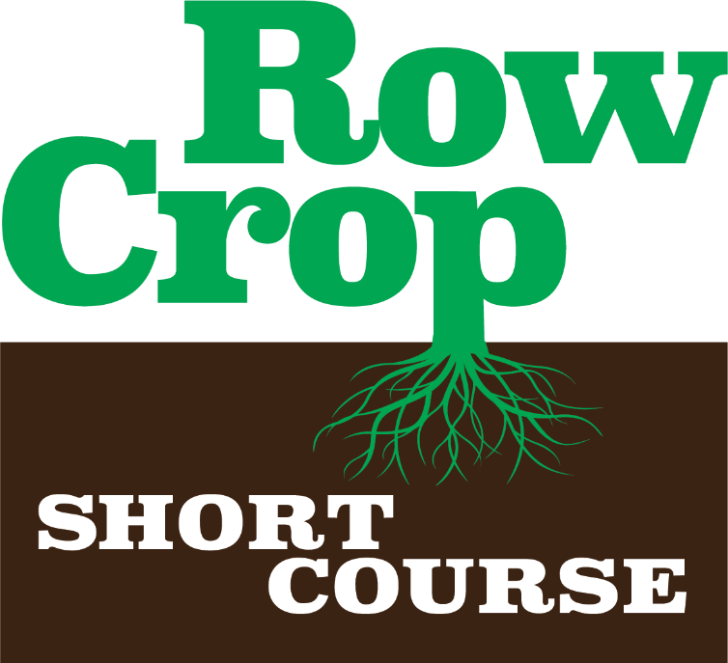

Follow Us on Social Media:

Facebook: Mississippi Crop Situation

Twitter: @mscrops

Instagram: mississippicrops

